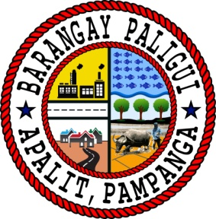Republic of the Philippines

Region III

Province of Pampanga

Municipality of Apalit

**BARANGAY PALIGUI**

*Office of the Sangguniang Kabataan*

Subject: Excuse Letter for Absence

To Whom It May Concern:

Greetings of Peace!

The Local Government of the Municipality of Apalit Pampanga, in its progressive existence aims to serve and promote their interest and enhance the talents of all aspiring young Apalitenos in the field of basketball. For this ground, the LGU of the Municipality of Apalit will be holding the 11th MJDT Basketball Cup on April 26, 2024 (Friday).

With this regards, we would like to request for your permission to allow the following players to be excused from their classes on April 23, 2024 (Tuesday) – Team Photoshoot and April 26, 2024 (Friday) – Opening Ceremony.

Listed below are the names of the basketball players:

1. Sam Jb Bernardo - Sta. Maria National High School
2. Leonel Dale Fabian - Sta. Maria National High School
3. Tom Aldrin Villarico - Sta. Maria National High School
4. Vince Padilla - Pampanga Colleges
5. John Patrick Landig - Bro. Andrew Technical High School
6. Lei Reizen Roxas - St. Vincent Academy of Apalit
7. Liam Baylon - Assumpta Technical High School
8. Adrian Louie Pingol - DHVSU Apalit Campus
9. Edmar Dizon - DHVSU Apalit Campus

We are hoping for your positive response.

Thank you and God Bless!

Very truly yours,

**ENGR. KENNETH D. BAUTISTA**

SK Secretary

Noted by:

**HON. ARJAY L. SACLAO**

SK Chairperson

Approved by:

**HON. HERMINIGILDO A. AQUINO**

Barangay Chairman